1. IAM settings are not regional, they are global.

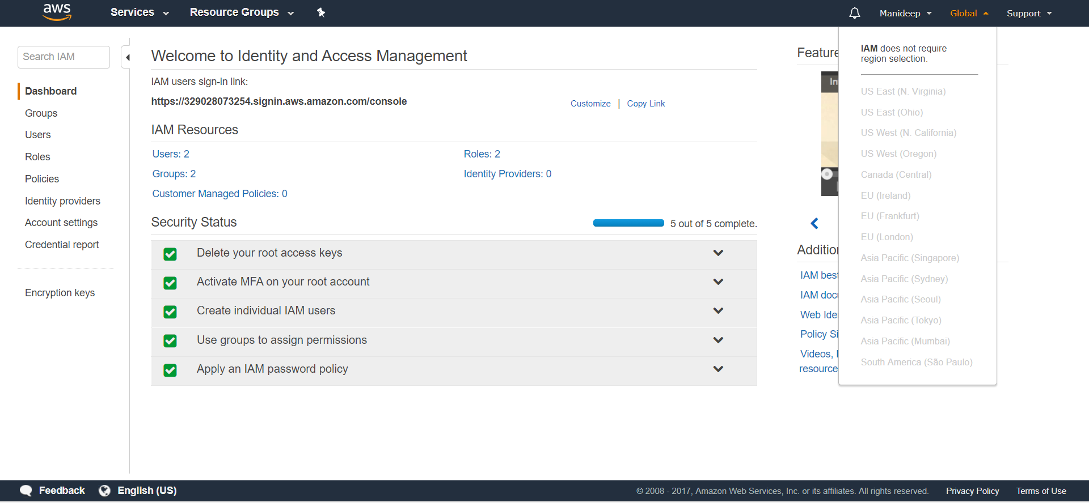

2. by default users have no permissions when first added.

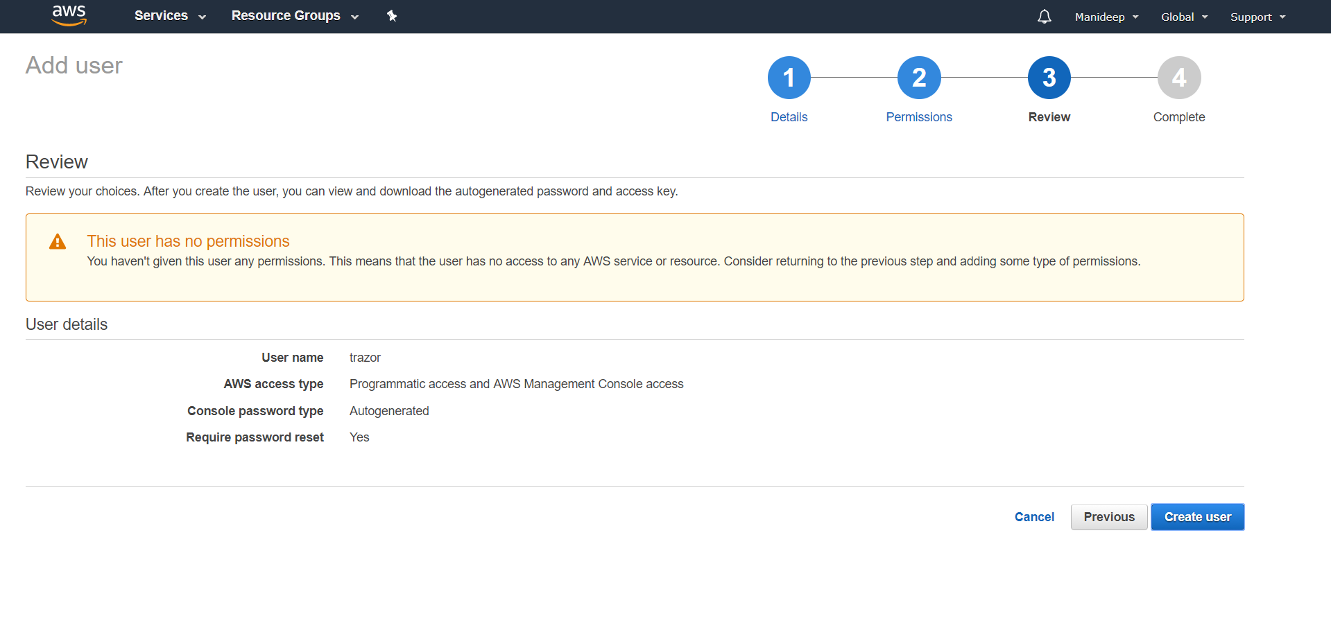

3. Active Directory Federation (AD) Can authenticate to AWS with AD using SAML.

If your organization already uses an identity provider software package that supports SAML 2.0 (Security Assertion Markup Language 2.0), you can create trust between your organization as an identity provider (IdP) and AWS as the service provider. You can then use SAML to provide your users with federated single-sign on (SSO) to the AWS Management Console or federated access to call AWS APIs. For example, if your company uses Microsoft Active Directory and Active Directory Federation Services, then you can federate using SAML 2.0. For more information about federating users with SAML 2.0

4. Web identify federation to AWS via facebook or social sites.

Yes, by web identify federation we can access to any social sites.

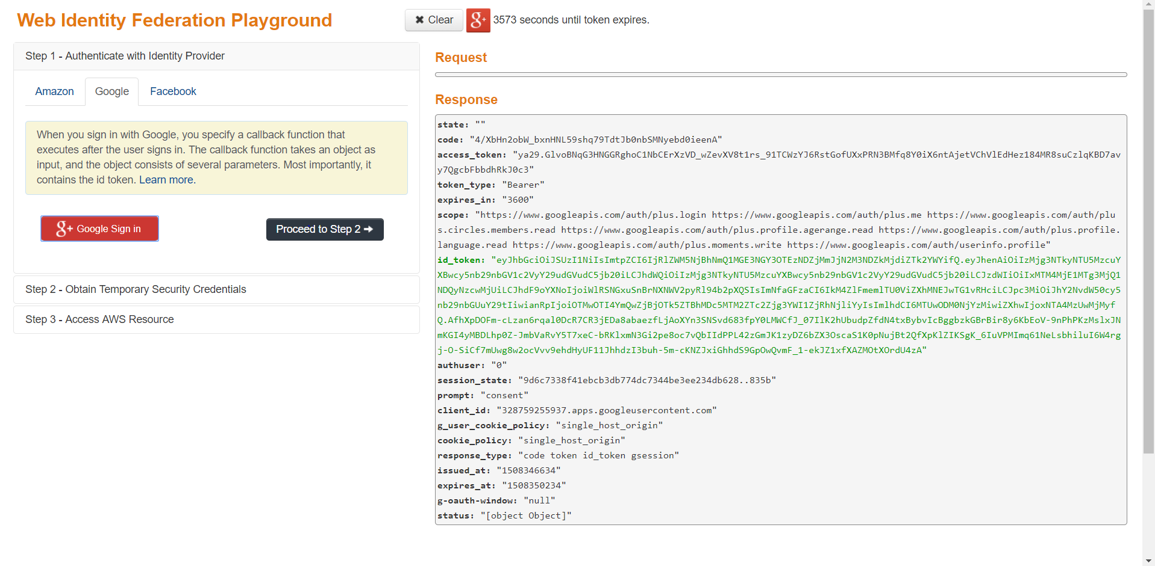

5. We can get temporary security credentials by calling the assume role with WebIdentify then we can access AWS resources by list bucket or get object.